Maria Hall April Activities – 2025
Sunday | Monday | Tuesday | Wednesday | Thursday | Friday | Saturday
 |  | 1 | 2 | 3 | 4 | 5
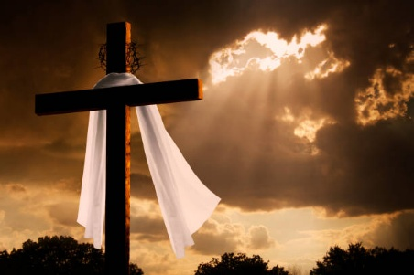 | 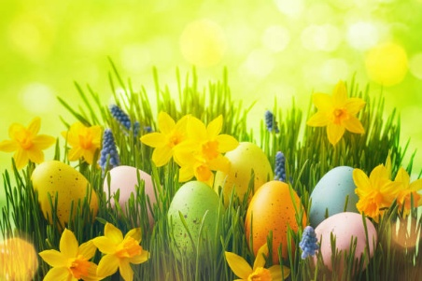 | 10:15am Exercise (3rd Floor)  11:00am Mass (Chapel/CH 2493)  2:00pm Mindfulness Meditation in Chapel  2:30pm Manicures in the Maria Hall Lobby | 10:15am Exercise (3rd Floor)  11:00am Mass (Chapel/CH 2493)  2:30pm Christian Beck Performs in the Chapel | 10:15am Exercise (3rd Floor)  11:00am Mass (Chapel/CH 2493)  2:30pm Yoga w/ Debra (2nd Floor Woodside)  3:30pm Happy Hour | 10:15am Stations of the Cross  11:00am Mass (Chapel/CH 2493)  2:30pm Neighborhood Association Meeting | 10:15am Exercise w/ Sam (3rd Floor)  2:30pm Kevin Hill Saxophone in Chapel
6 | 7 | 8 | 9 | 10 | 11 | 12
10:15am Exercise w/ Sam (3rd Floor)  11:00am Mass in Chapel or Ch. 2493 | 10:15am Exercise (3rd Floor)  11:00am Mass (Chapel/CH 2493)  2:30pm Bingo (MH Lobby) | 10:15am Exercise (3rd Floor)  11:00am Mass (Chapel/CH 2493)  2:00pm Mindfulness Meditation in Chapel  2:30pm Art Studio | 10:00-11:30am Transition Support Group (3rd Fl)  11am-3pm Candy for Caring in Café  11:00am Mass (Chapel/CH 2493)  2:30pm Bunco Club | 10:15am Exercise (3rd Floor)  11:00am Mass (Chapel/CH 2493)  3:30pm Happy Hour | 10:00am Fish Fry Outing to Holy Name Parish  10:15am Stations of the Cross  11:00am Mass (Chapel/CH 2493)  1:30pm Wisdom Circle & Rosary | 10:15am Exercise w/ Sam (3rd Floor)  1:15pm Bingo with Sarah C. in the MH Lobby
Palm Sunday 13 | Pat O. Birthday 14 | 15 | 16 | 17 | Good Friday 18 | Holy Saturday 19
10:15am Exercise w/ Sam (3rd Floor)  11:00am Mass in Chapel or Ch. 2493 | 10:15am Exercise (3rd Floor)  11:00am Mass (Chapel/CH 2493)  2:30pm Bingo (MH Lobby) | 10:15am Exercise (3rd Floor)  11:00am Mass (Chapel/CH 2493)  2:00pm Mindfulness Meditation in Chapel  2:30pm Manicures in the Maria Hall Lobby | 10:15am Exercise (3rd Floor)  11:00am Mass (Chapel/CH 2493)  11am-3pm Craft Fair in Café  1:00pm Food Committee meeting in MH Lobby | 10:15am Exercise (3rd Floor)  11:00am Mass (Chapel/CH 2493)  2:30pm Yoga w/ Debra (2nd Floor Woodside)  3:30pm Happy Hour | 10:15am Stations of the Cross  11:00am Mass (Chapel/CH 2493)  1:30pm Wisdom Circle & Rosary | 10:15am Exercise w/ Sam (3rd Floor)  1:15pm Bingo with Sarah C. in the MH Lobby
Easter Sunday 20 | 21 | 22 | 23 | 24 | 25 | 26
Glenda HC. Birthday  10:15am Exercise w/ Sam (3rd Floor)  11:00am Mass in Chapel or Ch. 2493 | 10:15am Exercise (3rd Floor)  11:00am Mass (Chapel/CH 2493)  2:30pm FBLA Club Hosts Easter Party in Assembly Room | 10:15am Exercise (3rd Floor)  11:00am Mass (Chapel/CH 2493)  2:00pm Mindfulness Meditation in Chapel  3:00pm Frazier Museum Stories in Mind (MH Lobby) | 10:15am Exercise (3rd Floor)  11:00am Mass (Chapel/CH 2493)  2:30pm Blackjack in MH Lobby  3:30pm Community Education Series in the Chapel | 10:15am Exercise (3rd Floor)  11:00am Mass (Chapel/CH 2493)  3:30pm Happy Hour | 10:15am Exercise (3rd Floor)  11:00am Mass (Chapel/CH 2493)  1:30pm Wisdom Circle & Rosary  2:30pm Lovasco & Emery Concert in Chapel | 11am Coffee and Current Events in the Café  1:15pm Bingo with Sarah C. in the MH Lobby
27 | 28 | 29 | 30
10:15am Exercise w/ Sam (3rd Floor)  11:00am Mass in Chapel or Ch. 2493 | 10:15am Exercise (3rd Floor)  11:00am Mass (Chapel/CH 2493)  2:30pm Bingo (MH Lobby) | 10:15am Exercise (3rd Floor)  11:00am Mass (Chapel/CH 2493)  2:00pm Mindfulness Meditation in Chapel  2:30pm Curtis Williams Performs on Maria Hall Patio | 10:15am Exercise (3rd Floor)  11:00am Mass (Chapel/CH 2493)  4:30pm Maria Hall Supper Club | 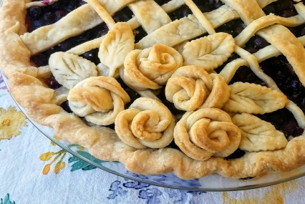 | 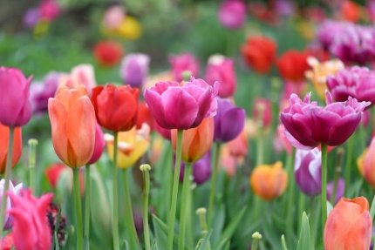 | << All activities are subject to change. Please see Life Enrichment Team with any questions. >>

