Charity Court April Activities – 2025
Sunday | Monday | Tuesday | Wednesday | Thursday | Friday | Saturday
 |  | 1 | 2 | 3 | 4 | 5
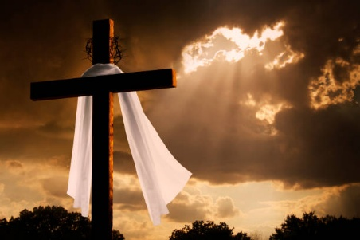 | 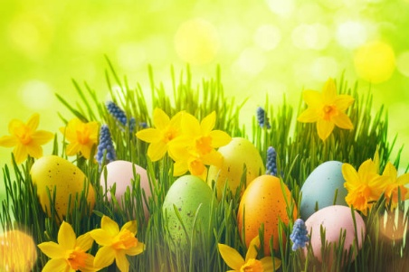 | 9:30am Sunrise Exercise/Trivia  11:00am Mass  11:30am Sunset Exercise/Trivia  1:00pm Beauty Shop  2:00pm Manicures | 9:30am Sunrise Exercise/Trivia  11:00am Mass  11:30am Sunset Exercise/Trivia  2:30pm Christian Beck Performs in the Chapel | 9:30am Sunrise Exercise/Trivia  11:00am Mass  11:30am Sunset Exercise/Trivia  2:00pm Rosary  2:30pm Game Time | 9:30am Sunrise Exercise/Trivia  11:00am Mass  11:30am Sunset Exercise/Trivia  2:00pm Patio Time  3:30pm Movie Matinee | 9:45am Sunset Exercise  10:15am Sunrise Exercise  11:00am Trivia/Games  2:30pm Kevin Hill Saxophone in Chapel  3:30pm BINGO
6 | 7 | 8 | 9 | 10 | 11 | 12
11:00am Mass in Our Lady of Nazareth Chapel  2:00pm Game Time  3:00pm Singing Circle | 9:30am Sunrise Exercise/Trivia  11:00am Mass  11:30am Sunset Exercise/Trivia  1:00pm 1 on 1 Time  2:00pm Art Studio | 9:30am Sunrise Exercise/Trivia  11:00am Mass  11:30am Sunset Exercise/Trivia  1:00pm Beauty Shop  2:00pm Manicures | 9:30am Sunrise Exercise/Trivia  11:00am Mass  11:30am Sunset Exercise/Trivia  2:00pm Baking Day | 9:30am Sunrise Exercise/Trivia  11:00am Mass  11:30am Sunset Exercise/Trivia  2:00pm Rosary  2:30pm Game Time | 9:30am Sunrise Exercise/Trivia  11:00am Mass  11:30am Sunset Exercise/Trivia  2:00pm Patio Time  3:30pm Movie Matinee | 9:45am Sunset Exercise  10:15am Sunrise Exercise  11:00am Trivia/Games  2:30pm Sing Along  3:30pm BINGO
Palm Sunday 13 | Mary Carmel Birthday 14 | 15 | Ann B. Birthday 16 | 17 | Good Friday 18 | Holy Saturday 19
11:00am Mass in Our Lady of Nazareth Chapel  2:00pm Game Time  3:00pm Singing Circle | 9:30am Sunrise Exercise/Trivia  11:00am Mass  11:30am Sunset Exercise/Trivia  1:00pm 1 on 1 Time  2:00pm Art Studio | 9:30am Sunrise Exercise/Trivia  11:00am Mass  11:30am Sunset Exercise/Trivia  1:00pm Beauty Shop  2:00pm Manicures | 9:30am Sunrise Exercise/Trivia  11:00am Mass  11:30am Sunset Exercise/Trivia  2:00pm Baking Day | 9:30am Sunrise Exercise/Trivia  11:00am Mass  11:30am Sunset Exercise/Trivia  2:00pm Rosary  2:30pm Game Time | 9:30am Sunrise Exercise/Trivia  11:00am Mass  11:30am Sunset Exercise/Trivia  2:00pm Patio Time  3:30pm Movie Matinee | 9:45am Sunset Exercise  10:15am Sunrise Exercise  11:00am Trivia/Games  2:30pm Sing Along  3:30pm BINGO
Easter Sunday 20 | 21 | 22 | Agnes E. Birthday 23 | Sharon T. Birthday 24 | 25 | 26
11:00am Mass in Our Lady of Nazareth Chapel  2:00pm Game Time  3:00pm Singing Circle | 9:30am Sunrise Exercise/Trivia  11:00am Mass  11:30am Sunset Exercise/Trivia  2:30pm FBLA Club Hosts Easter Party in Assembly Room | 9:30am Sunrise Exercise/Trivia  11:00am Mass  11:30am Sunset Exercise/Trivia  1:00pm Beauty Shop  2:00pm Manicures | 9:30am Sunrise Exercise/Trivia  11:00am Mass  11:30am Sunset Exercise/Trivia  2:00pm Baking Day | 9:30am Sunrise Exercise/Trivia  11:00am Mass  11:30am Sunset Exercise/Trivia  2:00pm Rosary  2:30pm Game Time | 9:30am Sunrise Exercise/Trivia  11:00am Mass  11:30am Sunset Exercise/Trivia  2:30pm Lovasco & Emery Concert in Chapel | 9:45am Sunset Exercise  10:15am Sunrise Exercise  11:00am Trivia/Games  2:30pm Sing Along  3:30pm BINGO
Margaret P. Birthday 27 | 28 | 29 | 30
11:00am Mass in Our Lady of Nazareth Chapel  2:00pm Game Time  3:00pm Singing Circle | 9:30am Sunrise Exercise/Trivia  11:00am Mass  11:30am Sunset Exercise/Trivia  1:00pm 1 on 1 Time  2:00pm Art Studio | 9:30am Sunrise Exercise/Trivia  11:00am Mass  11:30am Sunset Exercise/Trivia  2:30pm Curtis Williams on MH Patio | 9:30am Sunrise Exercise/Trivia  11:00am Mass  11:30am Sunset Exercise/Trivia  2:00pm Baking Day | 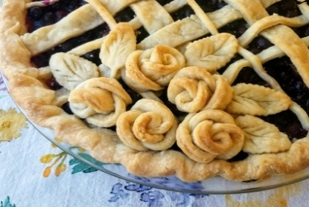 | 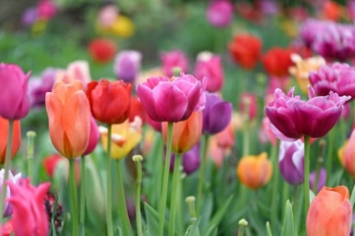 | << All activities are subject to change. Please see Life Enrichment Team with any questions. >>

