Maria Hall March Activities – 2025
Sunday | Monday | Tuesday | Wednesday | Thursday | Friday | Saturday
Ruth M. Birthday 2 | 3 | Mardi Gras 4 | Ash Wednesday 5 | Alice H. Birthday 6 | 7 | Carolyn S. Birthday 1/8
10:15 Exercise w/ Sam (3rd Floor)  11:00am Mass in Chapel or Ch. 2493 | 10:15am Exercise (3rd Floor)  11:00am Mass (Chapel/CH 2493)  2:30pm Bingo (MH Lobby) | 10:15am Exercise (3rd Floor)  11:00am Mass (Chapel/CH 2493)  2:00pm Mindfulness Meditation in Chapel  2:30pm Manicures in the Maria Hall Lobby | 10:15am Exercise (3rd Floor)  11:00am Mass (Chapel/CH 2493)  2:30pm Blackjack (MH Lobby) | 10:15am Exercise (3rd Floor)  11:00am Mass (Chapel/CH 2493)  2:30pm Yoga w/ Debra (2nd Floor Woodside)  3:30pm Happy Hour | 10:15am Stations of the Cross  11:00am Mass (Chapel/CH 2493)  2:30pm Neighborhood Association Meeting | 10:15 Exercise w/ Sam (3rd Floor)  1:15pm Bingo with Sarah C. in the MH Lobby
9 | “Lil” M. Birthday 10 | 11 | 12 | 13 | 14 | 15
10:15 Exercise w/ Sam (3rd Floor)  11:00am Mass in Chapel or Ch. 2493 | 10:15am Exercise (3rd Floor)  11:00am Mass (Chapel/CH 2493)  1:30pm Bingo (MH Lobby)  2:30pm Steve Bays Pianist in Chapel | 10:15am Exercise (3rd Floor)  11:00am Mass (Chapel/CH 2493)  2:00pm Mindfulness Meditation in Chapel  3:00pm Frazier Museum Stories in Mind (MH Lobby) | 10:00-11:30am Transition Support Group (3rd Fl)  11am-3pm Candy for Caring in Café  11:00am Mass (Chapel/CH 2493)  2:30pm Bunco Club | 10:15am Exercise (3rd Floor)  11:00am Mass (Chapel/CH 2493)  3:30pm Happy Hour | 10:15am Stations of the Cross  11:00am Mass (Chapel/CH 2493)  1:30pm Wisdom Circle  2:30pm Movie and Popcorn in MH Lobby | 10:15 Exercise w/ Sam (3rd Floor)  2:30pm Irish Dancers in Chapel
16 | St. Patrick’s Day 17 | 18 | 19 | 20 | 21 | 22
10:15 Exercise w/ Sam (3rd Floor)  11:00am Mass in Chapel or Ch. 2493  2:30pm Art with Sarah Lamb (Woodside) | 10:15am Exercise (3rd Floor)  11:00am Mass (Chapel/CH 2493)  2:30pm Bingo (MH Lobby) | 10:15am Exercise (3rd Floor)  11:00am Mass (Chapel/CH 2493)  2:00pm Mindfulness Meditation in Chapel  2:30pm Manicures in the Maria Hall Lobby | 10:15am Exercise (3rd Floor)  11:00am Mass (Chapel/CH 2493)  2:30pm 2nd Act Theater Performance in the Chapel | 10:15am Exercise (3rd Floor)  11:00am Mass (Chapel/CH 2493)  2:30pm Yoga w/ Debra (2nd Floor Woodside)  3:30pm Happy Hour | 10:15am Stations of the Cross  11:00am Mass (Chapel/CH 2493)  1:30pm Wisdom Circle  2:30pm Outing to Wal-Mart | 10:15 Exercise w/ Sam (3rd Floor)  2:30pm Tony Y Not Concert in Chapel
23 | 24 | 25 | 26 | 27 | 28 | 29
10:15 Exercise w/ Sam (3rd Floor)  11:00am Mass in Chapel or Ch. 2493 | 10:15am Exercise (3rd Floor)  11:00am Mass (Chapel/CH 2493)  1:30pm Bingo (MH Lobby)  2:30pm Mark Pyles in Chapel | 10:15am Exercise (3rd Floor)  11:00am Mass (Chapel/CH 2493)  2:00pm Mindfulness Meditation in Chapel  3:00pm Frazier Museum Stories in Mind (MH Lobby) | 10:15am Exercise (3rd Floor)  11:00am Mass (Chapel/CH 2493)  3:30pm Community Ed Series  4:30pm Maria Hall Supper Club | 10:15am Exercise (3rd Floor)  11:00am Mass (Chapel/CH 2493)  3:30pm Happy Hour | 10:15am Stations of the Cross  11:00am Mass (Chapel/CH 2493)  1:30pm Wisdom Circle  2:30pm Movie and Popcorn in Maria Hall Lobby | 11am Coffee and Current Events in the Café  1:15pm Bingo with Sarah C. in the MH Lobby
30 | 31
10:15 Exercise w/ Sam (3rd Floor)  11:00am Mass in Chapel or Ch. 2493 | 10:15am Exercise (3rd Floor)  11:00am Mass (Chapel/CH 2493)  2:30pm Bingo (MH Lobby) | 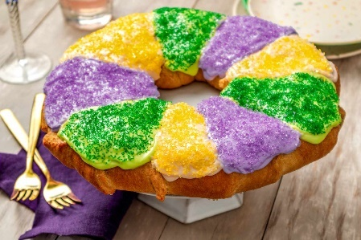 | 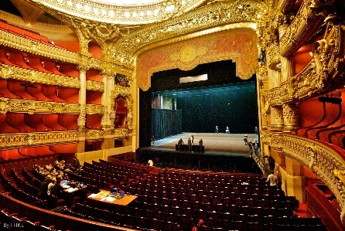 | 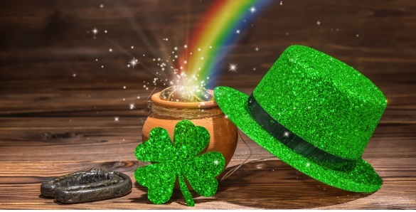 | 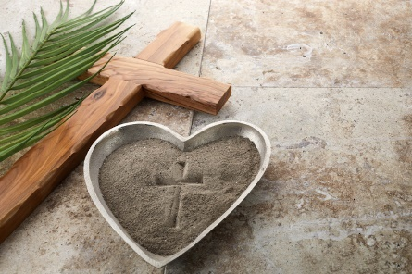 | << All activities are subject to change. Please see Life Enrichment Team with any questions. >>

