Maria Hall February Activities – 2025
Sunday | Monday | Tuesday | Wednesday | Thursday | Friday | Saturday
 |  |  |  |  |  | 1
 |  | 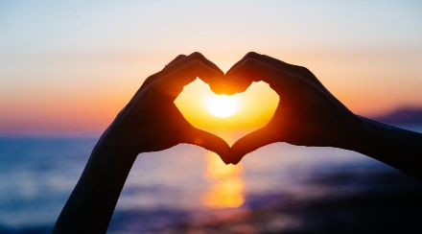 |  |  | 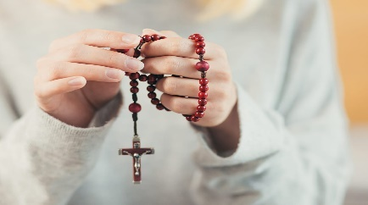 | 10:15 Exercise w/ Sam (3rd Floor)  1:15pm Games with Sarah C. in the MH Lobby
2 | 3 | 4 | 5 | 6 | 7 | 8
10:15 Exercise w/ Sam (3rd Floor)  11:00am Mass in Chapel or Ch. 2493  2:00pm Sunday Cinema (2nd Floor Woodside) | 10:15am Exercise (3rd Floor)  11:00am Mass (Chapel/CH 2493)  2:30pm Bingo (MH Lobby) | 10:15am Exercise (3rd Floor)  11:00am Mass (Chapel/CH 2493)  2:00pm Mindfulness Meditation in Chapel  2:30pm Valentine’s Day Art Project (MH Lobby) | 10:15am Exercise (3rd Floor)  11:00am Mass (Chapel/CH 2493)  2:30pm Blackjack (MH Lobby) | 10:15am Exercise (3rd Floor)  11:00am Mass (Chapel/CH 2493)  2:30pm Yoga w/ Debra (2nd Floor Woodside)  3:30pm Happy Hour | 10:15am Exercise (3rd Floor)  11:00am Mass (Chapel/CH 2493)  2:30pm Neighborhood Association Meeting | 10:15 Exercise w/ Sam (3rd Floor)  2:30pm President Abe & Mary Todd Lincoln Presentation in Chapel
9 | 10 | 11 | 12 | 13 | Valentine’s Day 14 | 15
10:15 Exercise (3rd Floor)  11:00am Mass in Chapel  2:30pm Art Class w/ Sarah Lamb on 2nd Floor Woodside  6:00pm Super Bowl Watch Party in MH Lobby | 10:15am Exercise (3rd Floor)  11:00am Mass (Chapel/CH 2493)  1:30pm Bingo (MH Lobby)  2:30pm Steve Bays Piano Performance in Chapel | 10:15am Exercise (3rd Floor)  11:00am Mass (Chapel/CH 2493)  2:00pm Mindfulness Meditation in Chapel  3:00pm Frazier Museum Stories in Mind (MH Lobby) | 10:15am Exercise (3rd Floor)  10:00-11:30am Approaching the Transition Support Group  11:00am Mass (Chapel/CH 2493)  2:30pm Bunco (MH Lobby) | 10:15am Exercise (3rd Floor)  11:00am Mass (Chapel/CH 2493)  3:30pm Happy Hour | 10:15am Exercise (3rd Floor)  11:00am Mass (Chapel/CH 2493)  1:30pm Wisdom Circle  2:30pm Marie Augustine Concert in Chapel | 10:15 Exercise w/ Sam (3rd Floor)  2:30pm Curtis Williams Concert in Chapel or CH 2493
16 | 17 | 18 | 19 | 20 | 21 | 22
10:15 Exercise w/ Sam (3rd Floor)  11:00am Mass in Chapel or Ch. 2493 | 10:15am Exercise (3rd Floor)  11:00am Mass (Chapel/CH 2493)  2:30pm Bingo (MH Lobby) | 10:15am Exercise (3rd Floor)  11:00am Mass (Chapel/CH 2493)  2:00pm Mindfulness Meditation in Chapel  2:30pm Hospitality Mtg | 10:15am Exercise (3rd Floor)  11:00am Mass (Chapel/CH 2493)  2:30pm Left, Right, Center (MH Lobby) | 10:15am Exercise (3rd Floor)  11:00am Mass (Chapel/CH 2493)  2:30pm Yoga w/ Debra (2nd Floor Woodside)  3:30pm Happy Hour | 10:15am Exercise (3rd Floor)  11:00am Mass (Chapel/CH 2493)  1:30pm Wisdom Circle  2:30pm Movie Matinee & Popcorn | 10:15 Exercise w/ Sam (3rd Floor)  11am Coffee and Current Events in the Café  1:15pm Games with Sarah C. in the MH Lobby
23 | 24 | 25 | 26 | 27 | 28
10:15 Exercise w/ Sam (3rd Floor)  11:00am Mass in Chapel or Ch. 2493 | 10:15am Exercise (3rd Floor)  11:00am Mass (Chapel/CH 2493)  1:30pm Bingo (MH Lobby)  2:30pm Misha Feigin Piano Concert in Chapel | 10:15am Exercise (3rd Floor)  11:00am Mass (Chapel/CH 2493)  2:00pm Mindfulness Meditation in Chapel  3:00pm Frazier Museum Stories in Mind (MH Lobby) | 10:15am Exercise (3rd Floor)  11:00am Mass (Chapel/CH 2493)  2:30pm Don Watson Concert in Chapel  4:30pm Maria Hall Supper Club | 10:15am Exercise (3rd Floor)  11:00am Mass (Chapel/CH 2493)  3:30pm Happy Hour | 10:15am Exercise (3rd Floor)  11:00am Mass (Chapel/CH 2493)  1:30pm Wisdom Circle  2:30pm Movie Matinee & Popcorn | << All activities are subject to change. Please see Life Enrichment Team with any questions. >>

