Gardenside February Activities – 2025
Sunday | Monday | Tuesday | Wednesday | Thursday | Friday | Saturday
 |  |  |  |  |  | 1
 |  |  | 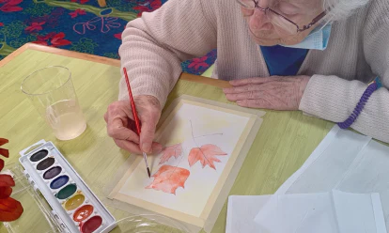 | 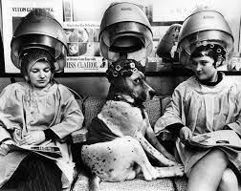 | 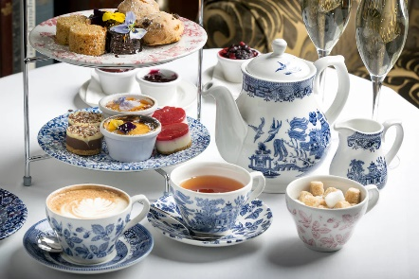 | 10:00am Coffee & Chicken Soup for the Soul  10:45am Active Game  2:00pm Afternoon Tea  3:30pm Exercise Class
2 | 3 | 4 | 5 | 6 | 7 | 8
10:00am Coffee & Chicken Soup for the Soul  11:00am Mass  1:30pm Baking  3:30pm Exercise Class | 10:00am Coffee & Chicken Soup for the Soul  11:00am Mass  1:30pm Armchair Travel  3:30pm Exercise Class | 10:00am Coffee & Chicken Soup for the Soul  11:00am Mass  1:30pm Rosary w/ Stacey  2:30pm Manicures  3:30pm Exercise Class | 10:00am Coffee & Chicken Soup for the Soul  11:00am Mass  1:30pm Art Studio  3:30pm Exercise Class | 10:00am Coffee & Chicken Soup for the Soul  11:00am Mass  2:30pm Beauty Shop  3:30pm Exercise Class | 10:00am Coffee & Chicken Soup for the Soul  11:00am Mass  1:30pm Game Time  3:30pm Exercise Class | 10:00am Coffee & Chicken Soup for the Soul  10:45am Active Game  2:30pm President Abe & Mary Todd Lincoln Presentation in Chapel  3:30pm Exercise Class
9 | 10 | 11 | 12 | 13 | Valentine’s Day 14 | 15
10:00am Coffee & Chicken Soup for the Soul  11:00am Mass  1:30pm Baking  3:30pm Exercise Class | 10:00am Coffee & Chicken Soup for the Soul  11:00am Mass  2:30pm Concert in Chapel  3:30pm Exercise Class | 10:00am Coffee & Chicken Soup for the Soul  11:00am Mass  1:30pm Rosary w/ Stacey  2:30pm Manicures  3:30pm Exercise Class | 10:00am Coffee & Chicken Soup for the Soul  11:00am Mass  1:30pm Art Studio  3:30pm Exercise Class | 10:00am Coffee & Chicken Soup for the Soul  11:00am Mass  2:30pm Beauty Shop  3:30pm Exercise Class | 10:00am Coffee & Chicken Soup for the Soul  11:00am Mass  2:30pm Concert in Chapel  3:30pm Exercise Class | 10:00am Coffee & Chicken Soup for the Soul  10:45am Active Game  2:30pm Concert in Chapel  3:30pm Exercise Class
16 | 17 | 18 | 19 | 20 | 21 | 22
10:00am Coffee & Chicken Soup for the Soul  11:00am Mass  1:30pm Baking  3:30pm Exercise Class | 10:00am Coffee & Chicken Soup for the Soul  11:00am Mass  1:30pm Armchair Travel  3:30pm Exercise Class | 10:00am Coffee & Chicken Soup for the Soul  11:00am Mass  1:30pm Rosary w/ Stacey  2:30pm Manicures  3:30pm Exercise Class | 10:00am Coffee & Chicken Soup for the Soul  11:00am Mass  1:30pm Art Studio  3:30pm Exercise Class | 10:00am Coffee & Chicken Soup for the Soul  11:00am Mass  2:30pm Beauty Shop  3:30pm Exercise Class | 10:00am Coffee & Chicken Soup for the Soul  11:00am Mass  1:30pm Game Time  3:30pm Exercise Class | 10:00am Coffee & Chicken Soup for the Soul  10:45am Active Game  2:00pm Afternoon Tea  3:30pm Exercise Class
23 | 24 | 25 | 26 | Ruth M. Birthday 27 | 28
10:00am Coffee & Chicken Soup for the Soul  11:00am Mass  1:30pm Baking  3:30pm Exercise Class | 10:00am Coffee & Chicken Soup for the Soul  11:00am Mass  1:00pm Armchair Travel  2:30pm Concert in Chapel  3:30pm Exercise Class | 10:00am Coffee & Chicken Soup for the Soul  11:00am Mass  1:30pm Rosary w/ Stacey  2:30pm Manicures  3:30pm Exercise Class | 10:00am Coffee & Chicken Soup for the Soul  11:00am Mass  2:30pm Concert in Chapel  3:30pm Exercise Class | 10:00am Coffee & Chicken Soup for the Soul  11:00am Mass  2:30pm Beauty Shop  3:30pm Exercise Class | 10:00am Coffee & Chicken Soup for the Soul  11:00am Mass  1:30pm Game Time  3:30pm Exercise Class | << All activities are subject to change. Please see Life Enrichment Team with any questions. >>

