Gardenside March Activities – 2025
Sunday | Monday | Tuesday | Wednesday | Thursday | Friday | Saturday
2 | 3 | 4 | 5 | 6 | Pat S. Birthday 7 | 8
10:00am Coffee & Chicken Soup for the Soul  11:00am Mass  1:30pm Baking  3:30pm Exercise Class | 10:00am Coffee & Chicken Soup for the Soul  11:00am Mass  1:30pm Armchair Travel  3:30pm Exercise Class | 10:00am Coffee & Chicken Soup for the Soul  11:00am Mass  1:30pm Rosary  2:30pm Manicures  3:30pm Exercise Class | 10:00am Coffee & Chicken Soup for the Soul  11:00am Mass  1:30pm Art Studio  3:30pm Exercise Class | 10:00am Coffee & Chicken Soup for the Soul  11:00am Mass  2:30pm Beauty Shop  3:30pm Exercise Class | 10:15am Stations of the Cross in the Chapel  11:00am Mass  1:30pm Game Time  3:30pm Exercise Class | 10:00am Coffee & Chicken Soup for the Soul  10:45am Active Game  2:00pm Afternoon Tea  3:30pm Exercise Class
9 | 10 | 11 | 12 | 13 | 14 | 15
10:00am Coffee & Chicken Soup for the Soul  11:00am Mass  1:30pm Baking  3:30pm Exercise Class | 10:00am Coffee & Chicken Soup for the Soul  11:00am Mass  2:30pm Steve Bays Piano Concert in Chapel  3:30pm Exercise Class | 10:00am Coffee & Chicken Soup for the Soul  11:00am Mass  1:30pm Rosary  2:30pm Manicures  3:30pm Exercise Class | 10:00am Coffee & Chicken Soup for the Soul  11:00am Mass  1:30pm Art Studio  3:30pm Exercise Class | 10:00am Coffee & Chicken Soup for the Soul  11:00am Mass  2:30pm Beauty Shop  3:30pm Exercise Class | 10:15am Stations of the Cross in the Chapel  11:00am Mass  2:30pm Concert in Chapel  3:30pm Exercise Class | 10:00am Coffee & Chicken Soup for the Soul  10:45am Active Game  2:30pm Irish Dancers in the Chapel
16 | St. Patrick’s Day 17 | 18 | 19 | 20 | 21 | 22
10:00am Coffee & Chicken Soup for the Soul  11:00am Mass  1:30pm Baking  3:30pm Exercise Class | 10:00am Coffee & Chicken Soup for the Soul  11:00am Mass  1:30pm Armchair Travel  3:30pm Exercise Class | 10:00am Coffee & Chicken Soup for the Soul  11:00am Mass  1:30pm Anointing of the Sick in Sunset  3:30pm Exercise Class | 10:00am Coffee & Chicken Soup for the Soul  11:00am Mass  2:30pm 2nd Act Theater Show in Chapel  3:30pm Exercise Class | 10:00am Coffee & Chicken Soup for the Soul  11:00am Mass  2:30pm Beauty Shop  3:30pm Exercise Class | 10:15am Stations of the Cross in the Chapel  11:00am Mass  1:30pm Game Time  3:30pm Exercise Class | 10:00am Coffee & Chicken Soup for the Soul  10:45am Active Game  2:30pm Concert in Chapel  3:30pm Exercise Class
23 | 24 | 25 | 26 | 27 | 28 | 29
10:00am Coffee & Chicken Soup for the Soul  11:00am Mass  1:30pm Baking  3:30pm Exercise Class | 10:00am Coffee & Chicken Soup for the Soul  11:00am Mass  2:30pm Mark Pyles in Chapel  3:30pm Exercise Class | 10:00am Coffee & Chicken Soup for the Soul  11:00am Mass  1:30pm Rosary  2:30pm Manicures  3:30pm Exercise Class | 10:00am Coffee & Chicken Soup for the Soul  11:00am Mass  1:30pm Art Studio  3:30pm Exercise Class | 10:00am Coffee & Chicken Soup for the Soul  11:00am Mass  2:30pm Beauty Shop  3:30pm Exercise Class | 10:15am Stations of the Cross in the Chapel  11:00am Mass  1:30pm Game Time  3:30pm Exercise Class | 10:00am Coffee & Chicken Soup for the Soul  10:45am Active Game  2:00pm Afternoon Tea  3:30pm Exercise Class
30 | 31
10:00am Coffee & Chicken Soup for the Soul  11:00am Mass  1:30pm Baking  3:30pm Exercise Class | 10:00am Coffee & Chicken Soup for the Soul  11:00am Mass  1:30pm Armchair Travel  3:30pm Exercise Class |  |  | 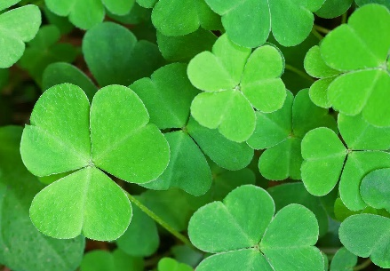 | 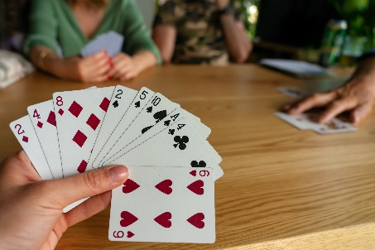 | << All activities are subject to change. Please see Life Enrichment Team with any questions. >>

