Charity Court March Activities – 2025
Sunday | Monday | Tuesday | Wednesday | Thursday | Friday | Saturday
2 | 3 | 4 | Ash Wednesday 5 | 6 | 7 | 8
11:00am Mass in Our Lady of Nazareth Chapel  2:00pm Game Time  3:00pm Singing Circle | 10:00am Sunset Exercise/Trivia  11:00am Mass  11:30am Sunrise Exercise/Trivia  1:00pm 1 on 1 Time  2:00pm Manicures | 10:00am Sunset Exercise/Trivia  11:00am Mass  11:30am Sunrise Exercise/Trivia  1:00pm Beauty Shop  2:00pm Mardi Gras Party | 10:00am Sunset Exercise/Trivia  11:00am Mass  11:30am Sunrise Exercise/Trivia  2:00pm Baking Day  4:00pm Puzzle Time | 10:00am Sunset Exercise/Trivia  11:00am Mass  11:30am Sunrise Exercise/Trivia  1:00pm Beauty Shop  2:00pm Rosary  3:00pm Bingo | 10:00am Sunset Exercise/Trivia  11:00am Mass  11:30am Sunrise Exercise/Trivia  2:00pm Patio Time  3:30pm Movie Matinee | 9:45am Sunset Exercise  10:15am Sunrise Exercise  11:00am Trivia/Games  2:30pm Sing Along  3:30pm BINGO
9 | 10 | Sr. MaryAnn Birthday11 | 12 | 13 | 14 | 15
11:00am Mass in Our Lady of Nazareth Chapel  2:00pm Game Time  3:00pm Singing Circle | 10:00am Sunset Exercise/Trivia  11:00am Mass  11:30am Sunrise Exercise/Trivia  1:00pm Manicures  2:30pm Steve Bays Piano in Chapel | 10:00am Sunset Exercise/Trivia  11:00am Mass  11:30am Sunrise Exercise/Trivia  1:00pm Beauty Shop  2:00pm Art Studio | 10:00am Sunset Exercise/Trivia  11:00am Mass  11:30am Sunrise Exercise/Trivia  2:00pm White Castle Wednesday  4:00pm Puzzle Time | 10:00am Sunset Exercise/Trivia  11:00am Mass  11:30am Sunrise Exercise/Trivia  1:00pm Beauty Shop  2:00pm Rosary  3:00pm The Price is Right | 10:00am Sunset Exercise/Trivia  11:00am Mass  11:30am Sunrise Exercise/Trivia  2:00pm Patio Time  3:30pm Movie Matinee | 9:45am Sunset Exercise  10:15am Sunrise Exercise  11:00am Trivia/Games  2:30pm Irish Dancers in the Chapel
16 | St. Patrick’s Day 17 | 18 | 19 | 20 | Carol W. Birthday 21 | 22
11:00am Mass in Our Lady of Nazareth Chapel  2:00pm Game Time  3:00pm Singing Circle | 10:00am Sunset Exercise/Trivia  11:00am Mass  11:30am Sunrise Exercise/Trivia  1:00pm 1 on 1 Time  2:00pm Manicures | 10:00am Sunset Exercise/Trivia  11:00am Mass  11:30am Sunrise Exercise/Trivia  1:00pm Beauty Shop  1:30pm Anointing of the Sick in Sunset | 10:00am Sunset Exercise/Trivia  11:00am Mass  11:30am Sunrise Exercise/Trivia  2:30pm 2nd Act Theater Show in Chapel  4:00pm Puzzle Time | 10:00am Sunset Exercise/Trivia  11:00am Mass  11:30am Sunrise Exercise/Trivia  1:00pm Beauty Shop  2:00pm Rosary  3:00pm Left, Right & Center | 10:00am Sunset Exercise/Trivia  11:00am Mass  11:30am Sunrise Exercise/Trivia  2:00pm Patio Time  3:30pm Movie Matinee | 9:45am Sunset Exercise  10:15am Sunrise Exercise  11:00am Trivia/Games  2:30pm Tony Y Not in Chapel  3:30pm BINGO
23 | 24 | 25 | 26 | 27 | 28 | 29
11:00am Mass in Our Lady of Nazareth Chapel  2:00pm Game Time  3:00pm Singing Circle | 10:00am Sunset Exercise/Trivia  11:00am Mass  11:30am Sunrise Exercise/Trivia  1:00pm 1 on 1 Time  2:30pm Mark Pyles Concert in Chapel | 10:00am Sunset Exercise/Trivia  11:00am Mass  11:30am Sunrise Exercise/Trivia  1:00pm Beauty Shop  2:00pm Art Studio | 10:00am Sunset Exercise/Trivia  11:00am Mass  11:30am Sunrise Exercise/Trivia  2:30pm Baking  4:00pm Puzzle Time | 10:00am Sunset Exercise/Trivia  11:00am Mass  11:30am Sunrise Exercise/Trivia  1:00pm Beauty Shop  2:00pm Rosary  3:00pm Uno | 10:00am Sunset Exercise/Trivia  11:00am Mass  11:30am Sunrise Exercise/Trivia  2:00pm Patio Time  3:00pm Movie Matinee | 9:45am Sunset Exercise  10:15am Sunrise Exercise  11:00am Trivia/Games  2:30pm Sing Along  3:30pm BINGO
30 | 31
11:00am Mass in Our Lady of Nazareth Chapel  2:00pm Game Time  3:00pm Singing Circle | 10:00am Sunset Exercise/Trivia  11:00am Mass  11:30am Sunrise Exercise/Trivia  1:00pm 1 on 1 Time  2:00pm Manicures |  | 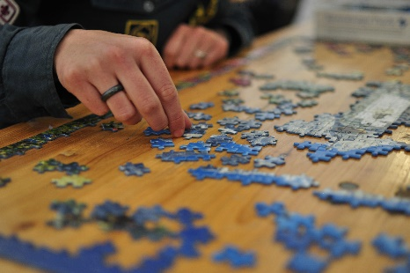 | 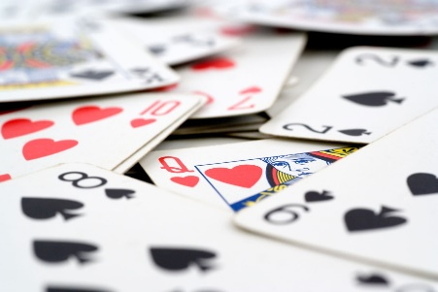 | 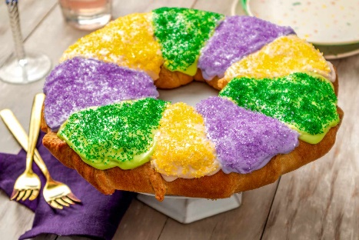 | << All activities are subject to change. Please see Life Enrichment Team with any questions. >>

