Maria Hall November Activities – 2024
Sunday | Monday | Tuesday | Wednesday | Thursday | Friday | Saturday
 |  |  |  |  | 1 | 2
<< All activities are subject to change. Please see Life Enrichment Team with any questions. >> | 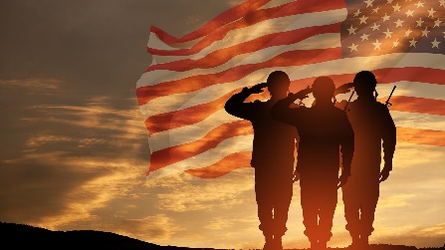 |  | 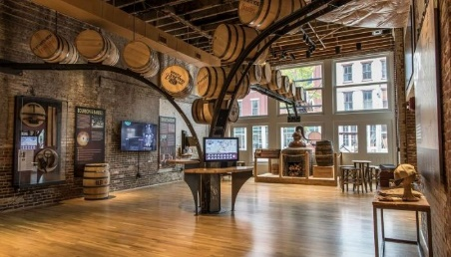 | 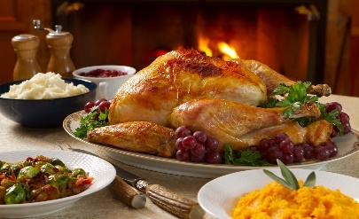 | 10:15am Exercise (3rd Floor)  11:00am Mass (Chapel/CH 2493)  2:30pm Neighborhood Association Meeting | 2:30pm Mark Pyles Concert in Chapel
3 | 4 | Election Day 5 | 6 | 7 | 8 | 9
11:00am Mass in Our Lady of Nazareth Chapel or Ch. 2493 | 10:15am Exercise (3rd Floor)  11:00am Mass (Chapel/CH 2493)  1:00pm One on One Visits  2:30pm Bingo (MH Lobby) | 10:15am Exercise (3rd Floor)  11:00am Mass (Chapel/CH 2493)  1:00pm Pet Therapy with Brea (Room to Room)  3:00pm Frazier Museum Stories in Mind (MH Lobby) | 10:15am Exercise (3rd Floor)  11:00am Mass (Chapel/CH 2493)  2:30pm Art Studio with Becca on 3rd Floor | 10:15am Exercise (3rd Floor)  11:00am Mass (Chapel/CH 2493)  2:30pm Yoga w/ Debra (2nd Floor Woodside)  3:30pm Happy Hour | 10:15am Exercise (3rd Floor)  11:00am Mass (Chapel/CH 2493)  2:30pm Tony Y-Not Concert in the Chapel | 1:15pm BINGO in the Maria Hall Lobby
10 | Veteran’s Day 11 | 12 | 13 | 14 | 15 | 16
11:00am Mass in Our Lady of Nazareth Chapel or Ch. 2493 | 10:15am Exercise (3rd Floor)  11:00am Mass (Chapel/CH 2493)  1:30pm Bingo (MH Lobby)  2:30pm Steve Bays Piano in the Chapel | 10:15am Exercise (3rd Floor)  11:00am Mass (Chapel/CH 2493)  2:30pm Young Heart Theatre in the Chapel | 10:00-11:30am Approaching the Transition Support Group (3rd Fl)  11:00am Mass (Chapel/CH 2493)  2:30pm Hospitality Committee Meeting | 10:15am Exercise (3rd Floor)  11:00am Mass (Chapel/CH 2493)  3:30pm Happy Hour | 10:15am Exercise (3rd Floor)  11:00am Mass (Chapel/CH 2493)  2:30pm Movie and Popcorn in MH Lobby | 2:30pm Doug Pinson Concert in Chapel
17 | 18 | Ethel R. Birthday 19 | Kathy B. Birthday 20 | 21 | 22 | 23
11:00am Mass in Our Lady of Nazareth Chapel or Ch. 2493 | 10:15am Exercise (3rd Floor)  11:00am Mass (Chapel/CH 2493)  1:00pm One on One Visits  2:30pm Bingo (MH Lobby) | 10:15am Exercise (3rd Floor)  11:00am Mass (Chapel/CH 2493)  1:00pm Pet Therapy with Brea (Room to Room)  3:00pm Frazier Museum Stories in Mind (MH Lobby) | 10:15am Exercise (3rd Floor)  11:00am Mass (Chapel/CH 2493)  11am-3pm Craft Fair in Café  4:00pm Happy Hour  5:00pm Supper Club | 10:15am Exercise (3rd Floor)  11:00am Mass (Chapel/CH 2493)  2:30pm Yoga w/ Debra (2nd Floor Woodside)  3:30pm Happy Hour and BU Student/Resident Theater performance in Cheers DR (2nd floor) | 10:15am Exercise (3rd Floor)  11:00am Mass (Chapel/CH 2493)  2:30pm Johnny Cash Video Tribute in the Chapel | 1:15pm BINGO in the Maria Hall Lobby
24 | 25 | 26 | 27 | Thanksgiving 28 | 29 | Janet B. Birthday 30
11:00am Mass in Our Lady of Nazareth Chapel or Ch. 2493 | 10:15am Exercise (3rd Floor)  11:00am Mass (Chapel/CH 2493)  1:00pm One on One Visits 2:30pm Bingo (MH Lobby) | 10:15am Exercise (3rd Floor)  11:00am Mass (Chapel/CH 2493)  1:00-4:00pm Traveling Nail Care Cart (Room to Room)  2:30pm Thanksgiving Prayer Service in Chapel | 10:15am Exercise (3rd Floor)  11:00am Mass (Chapel/CH 2493)  2:30pm Ice Cream Social | 11:00am Mass (Chapel/CH 2493)  2:30pm Thanksgiving Movie Challenge CH. 2490 – pick up a trivia sheet in the MH Lobby | 10:15am Exercise (3rd Floor)  11:00am Mass (Chapel/CH 2493)  2:30pm Movie and Popcorn in MH Lobby | 11am Coffee and Current Events in the Café  2:30pm Curtis Williams  Concert in Chapel

