Maria Hall September Activities – 2024
Sunday | Monday | Tuesday | Wednesday | Thursday | Friday | Saturday
1 | Barbara P. Birthday 2 | 3 | 4 | 5 | 6 | 7
11:00am Mass in Our Lady of Nazareth Chapel or Ch. 2493 | 10:15am Exercise (3rd Floor)  11:00am Mass (Chapel/CH 2493)  1:30pm Bingo (MH Lobby)  2:30pm Musical Fitness (Sunrise DR Spalding Square) | 10:15am Exercise (3rd Floor)  11:00am Mass (Chapel/CH 2493)  1:00pm Pet Therapy with Brea (Room to Room)  2:30pm Bunco (MH Lobby) | 10:15am Exercise (3rd Floor)  11:00am Mass (Chapel/CH 2493)  2:00pm Rosary and Faith Reflections (3rd Floor)  3:30pm Art Studio led by Becca (3rd Floor) | 10:15am Exercise (3rd Floor)  11:00am Mass (Chapel/CH 2493)  1:00pm Rosary (MH Lobby)  2:30pm Yoga w/ Debra (2nd Floor Woodside)  3:30pm Happy Hour | 10:15am Exercise (3rd Floor)  11:00am Mass (Chapel/CH 2493)  2:30pm Neighborhood Association Meeting | 1:15pm BINGO in the MH Lobby
8 | 9 | 10 | 11 | Mildred E. Birthday 12 | Jim J. Birthday 13 | 14
11:00am Mass in Our Lady of Nazareth Chapel or Ch. 2493  2:30pm Ice Cream Social with Julie! | 10:15am Exercise (3rd Floor)  11:00am Mass (Chapel/CH 2493)  1:00pm One on One Visits  2:30pm Bingo (MH Lobby) | 10:15am Exercise (3rd Floor)  11:00am Mass (Chapel/CH 2493)  1:00pm Pet Therapy with Brea (Room to Room)  3:00pm Frazier Museum Stories in Mind (MH Lobby) | 10:00-11:30am Approaching the Transition Support Group (3rd Fl)  11:00am Mass (Chapel/CH 2493)  2:30pm Sacrament of Anointing of the Sick and Rosary in the Chapel | 10:15am Exercise (3rd Floor)  11:00am Mass (Chapel/CH 2493)  1:00pm Rosary (MH Lobby)  3:30pm Happy Hour | 10:15am Exercise (3rd Floor)  11:00am Mass (Chapel/CH 2493)  2:30pm Tari Martin Performance in the Chapel | 1:15pm Games with Sarah C. in the MH Lobby
15 | 16 | 17 | 18 | 19 | 20 | 21
11:00am Mass in Our Lady of Nazareth Chapel or Ch. 2493 | 10:15am Exercise (3rd Floor)  11:00am Mass (Chapel/CH 2493)  1:30pm Bingo (MH Lobby)  2:30pm Lovasco & Emery Concert in Chapel | 10:15am Exercise (3rd Floor)  11:00am Mass (Chapel/CH 2493)  1:00-4:00pm Traveling Nail Care Cart (Room to Room) | 10:15am Exercise (3rd Floor)  11:00am Mass (Chapel/CH 2493)  2:00pm Rosary and Faith Reflections (3rd Floor)  6:00pm Remembrance Ritual in Chapel | 10:15am Exercise (3rd Floor)  11:00am Mass (Chapel/CH 2493)  1:00pm Rosary (MH Lobby)  2:30pm Yoga w/ Debra (2nd Floor Woodside)  3:30pm Happy Hour | 10:15am Exercise (3rd Floor)  11:00am Mass (Chapel/CH 2493)  2:00pm “Young Woman and the Sea” Watch Party on Woodside (2nd Floor) | 1:15pm BINGO in the MH Lobby
22 | 23 | 24 | 25 | 26 | Anne C. Birthday 27 | 28
11:00am Mass in Our Lady of Nazareth Chapel or Ch. 2493 | 10:15am Exercise (3rd Floor)  11:00am Mass (Chapel/CH 2493)  1:30pm Bingo (MH Lobby)  2:30pm Silver Notes Concert in Chapel | 10:15am Exercise (3rd Floor)  11:00am Mass (Chapel/CH 2493)  1:00pm Pet Therapy with Brea (Room to Room)  3:00pm Frazier Museum Stories in Mind (MH Lobby) | 10:15am Exercise (3rd Floor)  11:00am Mass (Chapel/CH 2493)  2:00pm Rosary and Faith Reflections (3rd Floor)  5:00pm Fall Fest Supper Club | 10:15am Exercise (3rd Floor)  11:00am Mass (Chapel/CH 2493)  1:00pm Rosary (MH Lobby)  3:30pm Happy Hour | 10:15am Exercise (3rd Floor)  11:00am Mass (Chapel/CH 2493)  2:30pm Bunco with Becca | 11am Coffee and Current Events in the Café  1:15pm BINGO in MH Lobby
29 | 30
11:00am Mass in Our Lady of Nazareth Chapel or Ch. 2493 | 10:15am Exercise (3rd Floor)  11:00am Mass (Chapel/CH 2493)  1:00pm One on One Visits  2:30pm Bingo (MH Lobby) | 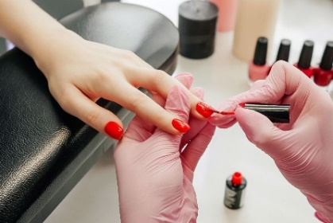 | 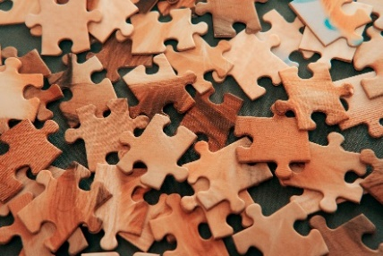 | 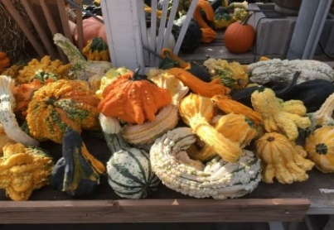 | 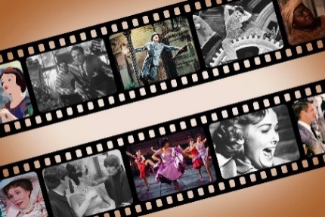 | << All activities are subject to change. Please see Life Enrichment Team with any questions. >>

