Charity Court September Activities – 2024
Sunday | Monday | Tuesday | Wednesday | Thursday | Friday | Saturday
1 | 2 | 3 | 4 | 5 | 6 | 7
11:00am Mass  1:00pm 1 on 1 Time  1:30pm Prayer and Exercise  2:00pm Krafts with Karen  3:00pm Reminisce and Sing | 10:00am Sunset Exercise/Trivia  11:00am Mass  11:30am Sunrise Exercise/Trivia  1:00pm 1 on 1 Time  2:30pm Manicures | 10:00am Sunset Exercise/Trivia  11:00am Mass  11:30am Sunrise Exercise/Trivia  1:00pm Beauty Shop  2:30pm Baking | 10:00am Sunset Exercise/Trivia  11:00am Mass  11:30am Sunrise Exercise/Trivia  2:00pm Gardening  4:00pm Puzzle Time | 10:00am Sunset Exercise/Trivia  11:00am Mass  11:30am Sunrise Exercise/Trivia  2:00pm Rosary  3:00pm Games | 10:00am Sunset Exercise/Trivia  11:00am Mass  11:30am Sunrise Exercise/Trivia  2:00pm Active Game  3:30pm Movie Matinee | 9:45am Sunset Exercise  10:15am Sunrise Exercise  11:00am Trivia/Games  2:30pm Sing Along  3:30pm BINGO
8 | 9 | 10 | 11 | 12 | 13 | 14
11:00am Mass  1:00pm 1 on 1 Time  1:30pm Prayer and Exercise  2:00pm Krafts with Karen  3:00pm Reminisce and Sing | 10:00am Sunset Exercise/Trivia  11:00am Mass  11:30am Sunrise Exercise/Trivia  1:00pm 1 on 1 Time  2:30pm Manicures | 10:00am Sunset Exercise/Trivia  11:00am Mass  11:30am Sunrise Exercise/Trivia  1:00pm Beauty Shop  2:30pm Art Studio | 10:00am Sunset Exercise/Trivia  11:00am Mass  11:30am Sunrise Exercise/Trivia  2:30pm Anointing of the Sick in the Chapel  4:00pm Puzzle Time | 10:00am Sunset Exercise/Trivia  11:00am Mass  11:30am Sunrise Exercise/Trivia  2:00pm Rosary  3:00pm Games | 10:00am Sunset Exercise/Trivia  11:00am Mass  11:30am Sunrise Exercise/Trivia  2:00pm Active Game  3:30pm Movie Matinee | 9:45am Sunset Exercise  10:15am Sunrise Exercise  11:00am Trivia/Games  2:30pm Sing Along  3:30pm BINGO
15 | 16 | 17 | 18 | 19 | 20 | 21
11:00am Mass  1:00pm 1 on 1 Time  1:30pm Prayer and Exercise  2:00pm Krafts with Karen  3:00pm Reminisce and Sing | 10:00am Sunset Exercise/Trivia  11:00am Mass  11:30am Sunrise Exercise/Trivia  1:00pm 1 on 1 Time  2:30pm Lovasco & Emery Concert in Chapel | 10:00am Sunset Exercise/Trivia  11:00am Mass  11:30am Sunrise Exercise/Trivia  1:00pm Beauty Shop  2:30pm Baking | 10:00am Sunset Exercise/Trivia  11:00am Mass  11:30am Sunrise Exercise/Trivia  2:00pm Manicures  4:00pm Puzzle Time | 10:00am Sunset Exercise/Trivia  11:00am Mass  11:30am Sunrise Exercise/Trivia  2:00pm Rosary  3:00pm Games | 10:00am Sunset Exercise/Trivia  11:00am Mass  11:30am Sunrise Exercise/Trivia  2:00pm Active Game  3:30pm Movie Matinee | 9:45am Sunset Exercise  10:15am Sunrise Exercise  11:00am Trivia/Games  2:30pm Sing Along  3:30pm BINGO
22 | Virginia H. Birthday 23 | 24 | 25 | 26 | Rose V. Birthday 27 | 28
11:00am Mass  1:00pm 1 on 1 Time  1:30pm Prayer and Exercise  2:00pm Krafts with Karen  3:00pm Reminisce and Sing | 10:00am Sunset Exercise/Trivia  11:00am Mass  11:30am Sunrise Exercise/Trivia  1:00pm 1 on 1 Time  2:30pm Silver Notes Concert in Chapel | 10:00am Sunset Exercise/Trivia  11:00am Mass  11:30am Sunrise Exercise/Trivia  1:00pm Beauty Shop  2:30pm Art Studio | 10:00am Sunset Exercise/Trivia  11:00am Mass  11:30am Sunrise Exercise/Trivia  2:00pm Gardening  4:00pm Puzzle Time | 10:00am Sunset Exercise/Trivia  11:00am Mass  11:30am Sunrise Exercise/Trivia  2:00pm Rosary  3:00pm Games | 10:00am Sunset Exercise/Trivia  11:00am Mass  11:30am Sunrise Exercise/Trivia  2:00pm Active Game  3:30pm Movie Matinee | 9:45am Sunset Exercise  10:15am Sunrise Exercise  11:00am Trivia/Games  2:30pm Sing Along  3:30pm BINGO
29 | 30
11:00am Mass  1:00pm 1 on 1 Time  1:30pm Prayer and Exercise  2:00pm Krafts with Karen  3:00pm Reminisce and Sing | 10:00am Sunset Exercise/Trivia  11:00am Mass  11:30am Sunrise Exercise/Trivia  1:00pm 1 on 1 Time  2:00pm Manicures | 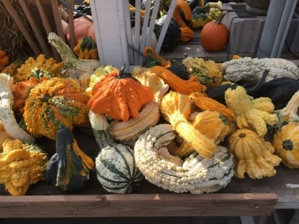 |  | 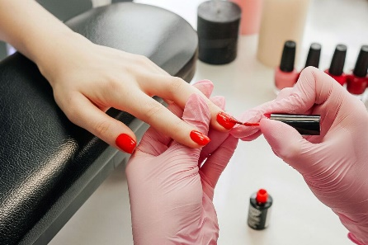 | 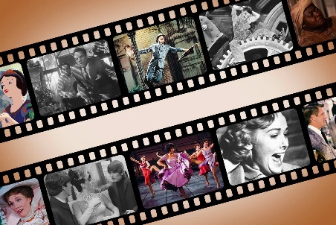 | << All activities are subject to change. Please see Life Enrichment Team with any questions. >>

